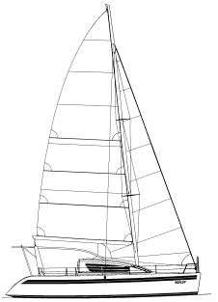
[date]

Jonathan & Susan Hacking
[home address]

Jon@HackingFamily.com
[home phone]

Superintendent of Customs,
Middle Point, Port Blair,
Andaman Nicobar Islands,
+91-(0)319-223-6368

Dear Sir,

I would like to inform you that the sailing catamaran Ocelot is now at Port Blair anchorage, awaiting customs clearance on arrival. The vessel has come from Phuket, Thailand to Port Blair. Please kindly issue an arrival clearance for the same.

The vessel particulars are as follows:

Vessel Name : | Ocelot
Type of vessel : | Sailing Catamaran
Flag : | USA
Registered Number : | [#]
Radio Call Sign : | [#]
Length : | 45’ (14m)
Beam : | 23’ (7m)
Draft : | 5’ (1.5m)
Displacement : | 18 tonnes

Our crew, including master, is as follows :

Surname | Given name | Date of birth | Nationality | Passport | Indian visa
Hacking | Xx | X | X | X | AP #
Hacking | Xx | x | x | x | AP #

We look forward to our receiving your clearance for arrival.

Sincerely,

(signed) Jonathan Hacking
Master and Captain of s/v Ocelot
http://HackingFamily.com http://svOcelot.com

