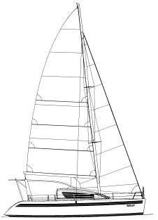
9 February 2011

Jonathan & Susan Hacking
12540 8th Ave NW
Seattle, WA 98177
USA

To whom it may concern,

This is a proposed (initial) Andaman Islands itinerary for S/V Ocelot:

Date (2011) | Proposed Destination | Actual Logged Destination
Thu 10 Feb | Arrive Port Blair
Fri 11 Feb | Port Blair
Sat 12 Feb | Port Blair
Sun 13 Feb | Havelock Island
Mon 14 Feb | Havelock Island
Tue 15 Feb | Havelock Island
Wed 16 Feb | Henry Lawrence Island
Thu 17 Feb | John Lawrence Island
Fri 18 Feb | Inglis Island
Sat 19 Feb | Middle Button Island
Sun 20 Feb | North Button Island
Mon 21 Feb | Spike Island
Tue 22 Feb | Havelock Island
Wed 23 Feb | Havelock Island
Thu 24 Feb | Havelock Island
Fri 25 Feb | Port Blair
Sat 26 Feb | Ross Island
Sun 27 Feb | Chiryatapu
Mon 28 Feb | Chiryatapu
Tue 1 Mar | Rutland Island
Wed 2 Mar | Rutland Island
Thu 3 Mar | Rutland Island
Fri 4 Mar | Twin Island
Sat 5 Mar | Chiryatapu
Sun 6 Mar | Port Blair
Mon 7 Mar | Port Blair
Tue 8 Mar | Port Blair
Wed 9 Mar | Depart Port Blair

The above is tentative & may have to change, especially for safety considerations. We will make every effort to notify the relevant officials if this becomes necessary.

Sincerely,

(signed) Jonathan Hacking
Master and Captain of s/v Ocelot
http://HackingFamily.com http://svOcelot.com

